Chapter 1

Circuit Variables

**مذكرات شرح وتمارين محلولة**

**امتحانات سابقة للعديد من المواد أدناه**

**متاحة مجاناً على الموقعين المذكورين أدناه**

**العجيب أن بعض الناس يفضلون من يكذب عليهم.**

* 1. **Electrical Engineering: An Overview**
* Electrical engineering is the profession concerned with systems that produce, transmit, and measure electric signals.
* **The five major classifications of electrical systems:**

1. **Communication systems:** Such as cameras, transmitters, receivers.
2. **Computer systems:** Such as personal computers.
3. **Control systems:** Such as control of temperatures, pressures, and flow rates in an oil refinery.
4. **Power systems:** Such as generators.
5. **Signal-processing systems:** Such as image-processing systems.

* **An electric circuit:**

Is a mathematical model that approximates the behavior of an actual electrical system.

**Note that:** the term electric circuit is commonly used to refer to an actual electrical system as well as to the model that represents it.

In this text, when we talk about an electric circuit, we always mean a model**.**

* الهندسة الكهربائية هي تلك المهنة التي تتعامل مع الأنظمة التي تنتج وتنقل الإشارات الكهربائية.

**لا ترض بأقل من التميز المطلـق.**

* 1. **The International System of Units**
* The SI units are based on seven basic units:

|  |  |  |
| --- | --- | --- |
| **TABLE 1.1 The international System of Units (SI)** | | |
| **Quantity** | **Basic Unit** | **Symbol** |
| **Length** | **Meter** | **m** |
| **Mass** | **kilogram** | **kg** |
| **Time** | **second** | **s** |
| **Electric current** | **ampere** | **A** |
| **Thermodynamic temperature** | **degree kelvin** | **K** |
| **Amount of substance** | **mole** | **mol** |
| **Luminous intensity** | **candela** | **cd** |

* In addition, defined quantities are combined to form derived units.

|  |  |  |
| --- | --- | --- |
| **TABLE 1.2 Derived Units in SI** | | |
| **Quantity** | **Unit Name (Symbol)** | **Formula** |
| **Frequency** | **Hertz (Hz)** | **s-1** |
| **Force** | **Newton (N)** | **Kg . m / s2** |
| **Energy or work** | **Joule (J)** | **N .m** |
| **Power** | **Watt (W)** | **J / s** |
| **Electric charge** | **Coulomb (C)** | **A . s** |
| **Electric potential (voltage)** | **Volt (V)** | **J / C** |
| **Electric resistance** | **Ohm (Ω)** | **V / A** |
| **Electric conductance** | **Siemens (S)** | **A / V** |
| **Electric capacitance** | **Farad (F)** | **C / V** |
| **Magnetic flux** | **Weber (Wb)** | **V . s** |
| **Inductance** | **Henry (H)** | **Wb / A**  **ابذل كل ما تستطيع لكل شيء أنت مسئول عنه.** |

* In many cases, the SI unit is either too small or too large to use conveniently. Standard prefixes corresponding to powers of 10 are applied to the basic unit.
* All of these prefixes are correct, but engineers often use only the ones for powers divisible by 3; thus centi, deci, deka, and hecto are used rarely.

|  |  |  |
| --- | --- | --- |
| **TABLE 1.3 Standardized Prefixes to Signify Powers of 10** | | |
| **Prefix** | **Symbol** | **Power** |
| **atto** | **a** | **10-18** |
| **femto** | **f** | **10-15** |
| **pico** | **p** | **10-12** |
| **nano** | **n** | **10-9** |
| **micro** | **µ** | **10-6** |
| **milli** | **m** | **10-3** |
| centi | c | 10-2 |
| deci | d | 10-1 |
| deka | da | 10 |
| **hecto** | **h** | **102** |
| **kilo** | **k** | **103** |
| **mega** | **M** | **106** |
| **giga** | **G** | **109** |
| **tera** | **T** | **1012** |

**وضع اللمسة الأخيرة على عملك بمثابة التاج الذي يكلل نجاحك.**

* 1. **Voltage and Current**
* **some important characteristics of electric charge:**

الخصائص الرئيسية للشحنات الكهربائية

* The charge is bipolar, meaning that electrical effects are described in terms of positive and negative charges.
* The electric charge exists in discrete quantities, which are integral multiples of the electronic charge, 1.6022 X 10-19 C.
* **Voltage** is the energy per unit charge created by the separation:

Where:

* **Electric current** is the rate of charge flow:

Where:

**المنافسة الحقيقية دائما تكون بين ما قمت بفعله وما أنت قادر على فعله.**

* Question 1.9:

The current entering the upper terminal of Fig. 1.5 is:

Assume the charge at the upper terminal is zero at the instant the current is passing through its maximum value. Find the expression for q(t).

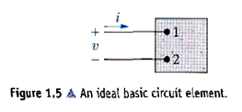

* + - ***Solution:***

Current is maximum when is maximum

**الذين يسعون دائما نحو التميز والأفضل يصبحون تلقائيا مثلا للآخرين.**

1. **The Ideal Basic Circuit Element**

الصفات الثلاث لنموذج عنصر دائرة كهربائية

* An ideal basic circuit element has three attributes:

1. it has only two terminals, which are points of connection to other circuit components.
2. it is described mathematically in terms of current and/or voltage.
3. it cannot be subdivided into other elements.



* passive sign convention:

Whenever the direction of current is same as the direction of voltage drop across the element (as in Fig.l.5), use a positive sign in any expression relateing voltage with current. Otherwise, use a negative sign.

إذا كان اتجاه التيار هو نفس اتجاه تناقص الفولت نستخدم علامة (+) في أي علاقة تربط الفولت مع التيار.

**الكثير من العمل الجيد يضيع بسبب العجز عن بذل ما هو أكثر قليلا.**

* Assessment problem 1.3:

|  |  |
| --- | --- |
| The current at the terminals of the element in Fig. 1.5 is  Calculate the total charge (in microcoulombs) entering the element at its upper terminal. |  |

* **Solution:**

**إذا أردت أن تنجز عملا بشكل جيد، فستجد وسيلة لإنجازه مهما كانت الظروف.**

1. **Power and Energy**

where:

= the power in watts, = the energy in joules, = the time in seconds.

Thus 1W is equivalent to 1 J/s.

* The power can be related with voltage and current as follows:

so

where:

= the power in watts, = the voltage in volts, = the current in amperes.

* Algebraic sign of power:

If the power is positive (that is, if p > 0), power is being delivered to the circuit inside the box. If the power is negative (that is, if p < 0), power is being extracted from the circuit inside the box.

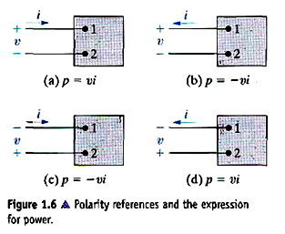

**إذا لم تعلم أين تذهب، فكل الطرق تفي بالغرض.**

* Assessment problem 1.5:

Assume that a 20 V voltage drop occurs across an element from terminal 2 to terminal 1 and that a current of 4 A enters terminal 2.

1. Specify the values of *v* and *i* for the polarity references shown in Fig. 1.6(a)-(d).
2. State whether the circuit inside the box is absorbing or delivering power.
3. How much power is the circuit absorbing?

**من المهم أن يكون لديك ما تستيقظ من أجله.**

* **Solution:**

|  |  |
| --- | --- |
| * Start by drawing a picture of the circuit described in the problem statement: |  |

1. Now we have to match the voltage and current shown in the left figure with the polarities shown in Fig. 1.6.

b,c) Using the reference system in Fig. 1.6(d) and the passive sign

convention,

* Assessment problem 1.6:

Assume that the voltage at the terminals of the element in Fig. 1.5 corresponding to the current in Assessment Problem 1.3 is

Calculate the total energy (in joules) delivered to the circuit element.

* Assessment problems 1.3:

The current at the terminals of the clement in Fig. 1.5 is

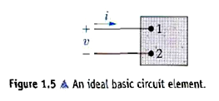

* **Soultion:**

**لا نتيجة بدون ألم**

**No gains without pains.**

* Question 1.11:

One 9 V battery supplies 100 mA to a camping flashlight. How much energy does the battery supply in 5 h?

* ***Solution:***

**الأماني رءوس أموال المفلسين.**

* Question 1.12:

Two electric circuits, represented by boxes A and B, are connected as shown in Fig. P1.12.The reference direction for the current in the interconnection and the reference polarity for the voltage v across the interconnection are as shown in the figure. For each of the following sets of numerical values, calculate the power in the interconnection and state whether the power is flowing from A to B or vice versa.

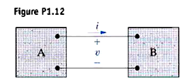

**إن لم تزد شيئا على الدنيا كنت أنت زائداً عليها. (مصطفى صادق الرافعي)**

* **Soultion:**

Since the current flows into terminal of voltage , we can use the equation without sign. if the power is , so it flows from A to B. if the power is , so it flows from B to A.

1. *p* = (-480)(-10) = 4800 W 4800 W from A to B

* Question 1.15:

When a car has a dead battery, it can often be started by connecting the battery from another car across its terminals. The positive terminals are connected together as are the negative terminals. The connection is illustrated in Fig. P1.15. Assume the current in Fig. P1.15 is measured and found to be 30 A.

1. Which car has the dead battery?
2. If this connection is maintained for 1 min, how much energy is transferred to the dead battery?



* **Soultion:**

1. Current flows from volt to volt in car A, So car A is absorbing power. Car A has the dead battery.

**الأمس شيك تم سحبه، والغد شيك مؤجل قد لا يتم صرفه، أما الحاضر فهو السيولة الوحيدة المتوفرة لديك.**

* Question 1.16:

The manufacturer of a 9 V dry-cell flashlight battery says that the battery will deliver 20 mA for 80 continuous hours. During that time the voltage will drop from 9 V to 6 V. Assume the drop in voltage is linear with time. How much energy does the battery deliver in this 80 h interval?

* **Soultion:**



**الأمور الصعبة تشبه قيادة السيارة في ظلام الليل، تستطيع الرؤية بقدر ما تكشفه أنوار السيارة لكنك غالبا ستكمل الرحلة.**

The voltage and current at the terminals of the circuit element in Fig. 1.5 are shown in Fig. P1.19.

a) Sketch the power versus t, plot for 0 ≤ t ≤ 50 s.

b) Calculate the energy delivered to the circuit element at t = 4, 12, 36, and 50 s.

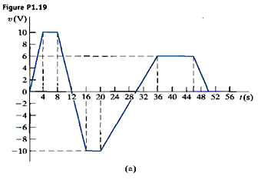

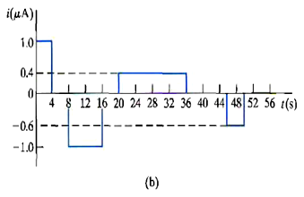

* Question 1.19:
* Solution:

|  |  |  |  |  |
| --- | --- | --- | --- | --- |
|  |  |  |  |  |
|  |  |  |  |  |
|  |  |  |  |  |
|  |  |  |  |  |

**ابدأ اليوم حتى لا تندم غداً على فوات الأوان.**

**- 3.6**

**2.4**

**- 4.0**

**- 10**

**10**

**10**

* **Continued (question 1.19):**



1. Calculate the area under the curve from zero up to 50 s:

**ابحث عن الحكمة لأنها لن تبحث عنك.**

* Question 1.22:

The voltage and current at the terminals of an auto-mobile battery during a charge cycle are shown in Fig. P1.22.

a) Calculate the total charge transferred to the battery.

b) Calculate the total energy transferred to the battery.

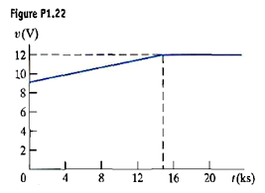

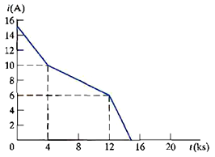

* **Soultion:**

**أليس من الممكن أن يكون وضعك الحالي أفضل وبنفس الإمكانات المتاحة.**

* **Continue (question 1.22):**

**أن تضيء شمعة صغيرة خير لك من أن تنفق عمرك تلعن الظلام.**

* Question 1.23:

The voltage and current at the terminals of the circuit element in Fig. 1.5 are zero for t < 0, and for t ≥ 0 they are:

1. At what instant of time is maximum power delivered to the element?
2. Find the maximum power in watts.
3. Find the total energy delivered to the element in millijoules.



**أليس من الممكن أن يكون وضعك الحالي أفضل وبنفس الإمكانات المتاحة.**

* **Soultion:**
* **Continued (question 1.23):**

**إذا لم تعمل شيئا غير استثنائي فلن تحصل إلا على الشيء العادي.**

* Question 1.25:

The voltage and current at the terminals of the circuit element in Fig. 1.5 are:

zero for t < 0, and for t ≥ 0 they are:

1. Find the time (in milliseconds) when the power delivered to the circuit element is maximum.
2. Find the maximum value of p in milliwatts.
3. Find the total energy delivered to the circuit element in millijoules.



* **Soultion:**

**أن تضيء شمعة صغيرة خير لك من أن تنفق عمرك تلعن الظلام.**

* **Continued (question 1.25):**

**هل تعرف أحدا عاش حياته مرتين؟**

**يمكنك ذلك من خلال دورة:**

**ضاعف حياتك، راسلنا عالإيميل**

* Question 1.26:

The numerical values for the currents and voltages in the circuit in Fig. P1.26 are given in Table P1.26.Find the total power developed in the circuit.

|  |  |
| --- | --- |
|  |  |

* **Soultion:**
* If the power is positive, the circuit element is absorbing, otherwise developing.
* The power balances (OK)

**توجد طريقة أفضل لعمل ذلك، ابحثوا عنها.**

**(توماس إديسون)**